Universidade Fernando Pessoa
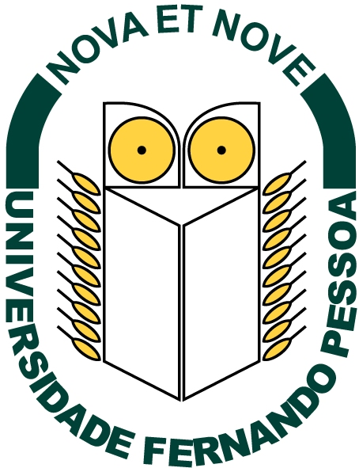
click on the underlined text
Seismic Sequential Stratigraphy
Carlos Cramez
with contributions from
Peter Vail and Shenghyu Wu

Send E-mail to carloscramez@gmail.com with questions and comments about these notes
Copyright © 2003 CCramez
Last modification: April, 2015

