Universidade Fernando Pessoa
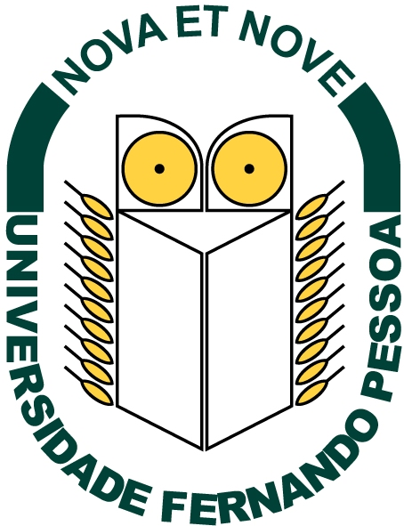
click on the underlined text
Glossary
of
Salt Tectonics
prepared
by
Carlos Cramez

Send E-mail to carloscramez@gmail.com with questions and comments about these notes
Copyright © 2006 CCramez
Last modification : August, 2014

